AMIS Meetup Oracle Cloud Native Application Development

January 20th 2020

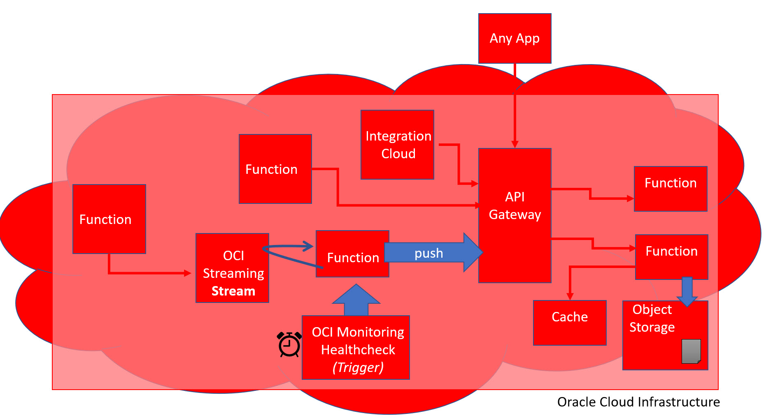

In this workshop, you will learn about Cloud Native Application Development on Oracle Cloud Infrastructure. You will see and use Functions, API Gateway, Object Storage, Streaming, Monitoring and more.

The workshop labs are provided in the shape of Katacoda scenarios. These are scenarios that combine step by step instructions with fully prepared, cloud based environments. Once you start a scenario, a Linux environment is spun up for you and necessary resources are installed into it, such as the OCI CLI and the Fn CLI as well as workshop sources from GitHub.

The workshop consists of the following scenarios:

1. Introduction to Serverless Functions with Project Fn - <https://katacoda.com/lucasjellema/scenarios/introduction-fn>
2. Serverless Functions on Oracle Cloud Infrastructure - <https://katacoda.com/lucasjellema/scenarios/functions-on-oci>
3. API Gateway on Oracle Cloud Infrastructure - <https://katacoda.com/lucasjellema/scenarios/api-gateway-on-oci>
4. Functions, Object Storage and API Gateway on Oracle Cloud Infrastructure - <https://katacoda.com/lucasjellema/scenarios/oci-functions-objects-apigateway>
5. OCI (Event) Streaming – combined with Functions and API Gateway - <https://katacoda.com/lucasjellema/scenarios/oci-streaming>

Please work your way through the scenarios in this order. Note that some scenarios rely on objects created in earlier scenarios.

The workshop environment is hosted on three different tenancies on Oracle Cloud Infrastructure (in the Ashburn region in US East). You might wonder why a single tenancy does not suffice. There is a limitation on the number of applications and functions (10 and 20) that can be created on a tenancy. This limit can be extended through Oracle Support and I have requested this. However, this request has not been processed yet – therefore I felt I needed to provision two additional tenancies in order to raise the combined limit to 60 functions.

Within each of these three tenancies, a lab compartment has been set up. In this compartment, a VCN with two subnets as well as an API Gateway and a Stream have been created. The user used by participants is *lab-user*. This user is member of the *lab-participants* group. This group is recipient of privileges on the afore mentioned resources and services as defined through a set of policies. Note: all participants use *lab-user*. They do so on three different OCI tenancies. Yet they will probably run into each other during the labs.

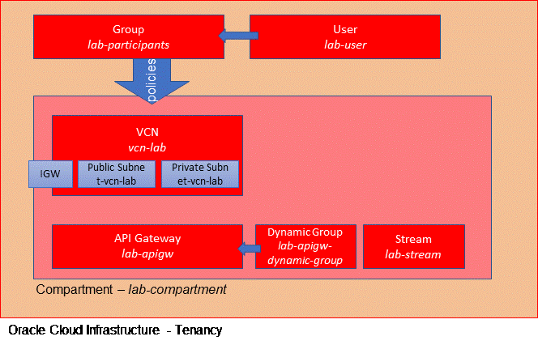

Participants can access the OCI Tenancy in three ways:

* Console
* OCI CLI
* REST APIs

The labs make primarily use of the OCI CLI and to some extent of the Console.

## Workshop Environments

Each participant is assigned a number (LAB_ID) that is used during the labs to prevent interference between the participants. Before you get going, make sure you know your own LAB_ID.

The Lab Id corresponds to one of three tenancies that have been set up for the workshop.

|  |  |  |
| --- | --- | --- |
| **Lab Id** | **OCI Tenancy Id** | **Credentials Document** |
| 1..10 | lucascloudlab | [credentials-lucascloudlab](https://objectstorage.us-ashburn-1.oraclecloud.com/p/AmuXdGd1hCMlPsfgj9ULwXIEVrRbbfGSZ6yKvzEsEx4/n/idtwlqf2hanz/b/cloud-native-lab-resources/o/lab-user-in-LUCASCLOUDLAB) |
| 11..20 | labuser2 | [Credentials-labuser2](https://objectstorage.us-ashburn-1.oraclecloud.com/p/3rpgphCjcBYJtlzVzOGONtXY4EvB0fRC4QwOazM_bjM/n/idtwlqf2hanz/b/cloud-native-lab-resources/o/lab-user-in-AMIS-LAB-USER2) |
| 20..31 | labuser3 | [Credentials-labuser3](https://objectstorage.us-ashburn-1.oraclecloud.com/p/ZOeGWkuylxfaHG80pAGfalxBL0E6UTtn47HHt5bSVGg/n/idtwlqf2hanz/b/cloud-native-lab-resources/o/lab-user-in-AMIS-LAB-USER3) |

The Credentials Document contains all details you will need during the workshop to access the OCI resources in various ways. There is a separate Credentials Document for each of the three tenancies. Make sure that you are using the right credentials document.

The credentials document contains the following credentials:

* Username and password for OCI Console
* (Docker) Username and password for OCIR (Oracle Container Image Registry)
* Contents for the OCI CLI configuration file (tenancy ocid, *lab-user* ocid, …)
* Private key for *lab-user*
* Contents for oci-configuration.js – a file used for Node applications that access OCI REST APIs

During the labs, you will occasionally need to copy and paste details from the credentials document to files in the Katacoda scenario environment.

## Working in the Console

When you work in the OCI console, there are a few things to remember:

* Go to the console URL for the right region: (ashburn: Console URL: <https://console.us-ashburn-1.oraclecloud.com/> )
* Set the right tenancy (one of the three)
* Login as Oracle Cloud Infrastructure (non-federated) user
* Select the right compartment (lab-compartment)

The login page looks like this:

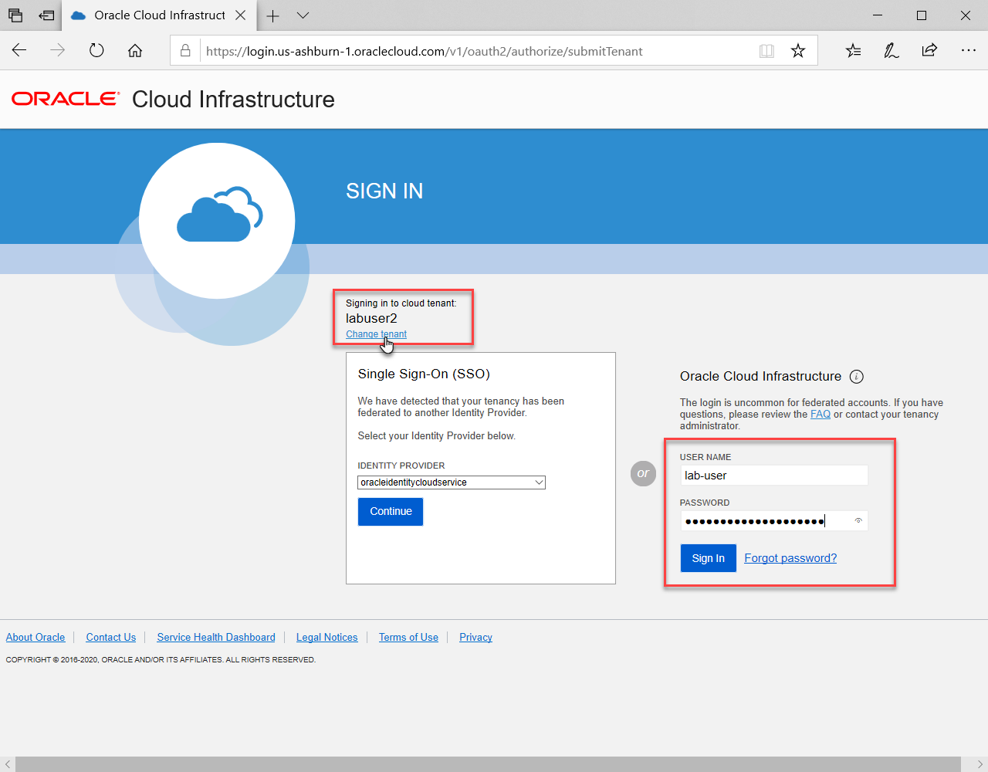

Do no press the button *Continue.* Use the Sign In button as credential fields. Use the *Change tenant* link if the desired tenant is not currently indicated. The form for changing the tenant looks like this:

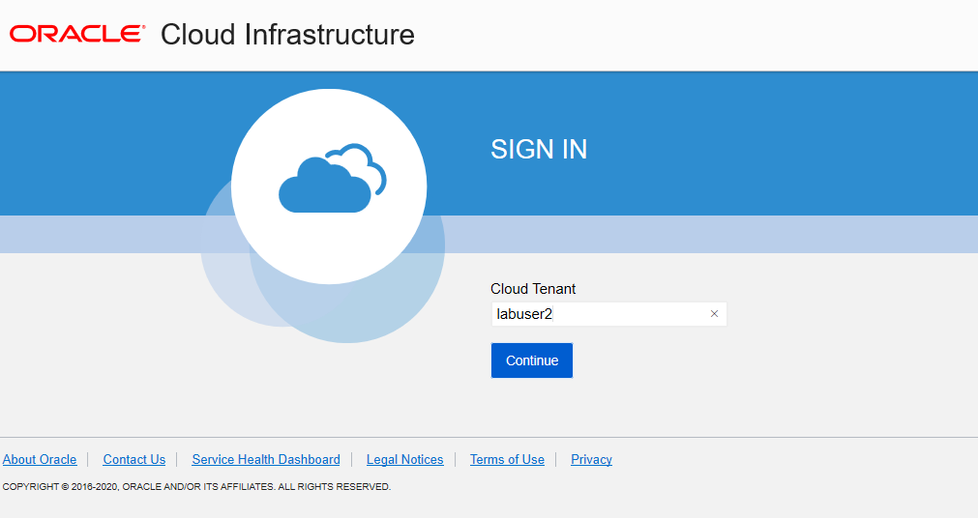

Once you are logged in, make sure to select the *lab-compartment* as the compartment context:

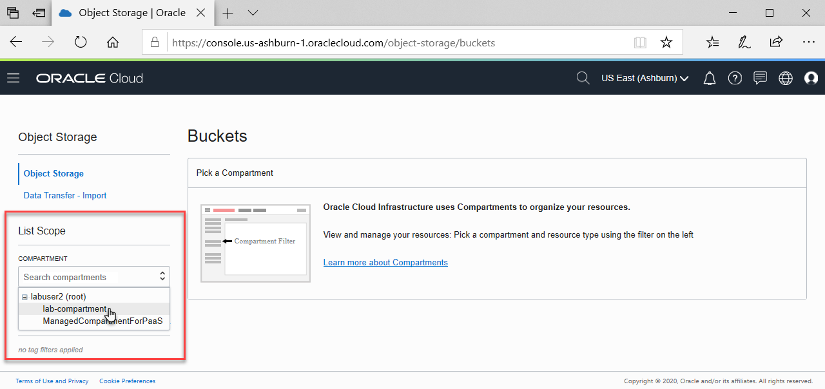

## Resources

GitHub Repo – workshop resources: <https://github.com/AMIS-Services/oracle-cloud-native-meetup-20-january-2020>

GitHub Repo – Katacoda Scenarios- <https://github.com/lucasjellema/katacoda-scenarios>